**MODULE: 1**

**SE – Overview of IT Industry**

**1. What is software? What is software engineering?**

Ans: -Software is the language of computer.

-Just like human language .

-Is a set of programs (sequence of instructions) that allows the user

to perform a well-defined function or some specified task.

-Software Engineering is the process of designing, developing, testing, and maintaining software. It is a systematic and disciplined approach to software development that aims to create high-quality, reliable, and maintainable software.

**2. Explain types of software:**

* Ans: -
* **1.Application software.**Application software is a type of computer program that performs a specific personal, educational, and business function. Each application is designed to assist end-users in accomplishing a variety of tasks, which may be related to productivity, creativity, or communication.
* **2.System software.** System software is a program designed to run a computer's hardware and applications and manage its resources, such as its memory, processors, and devices. It also provides a platform for running application software, and system software is typically bundled with a computer's operating system.

EX: Windows, Linux, MacOS X, BSD

* **3.Driver software.**Also known as device drivers, this software is often considered a type of system software. Device drivers control the devices and peripherals connected to a computer, enabling them to perform their specific tasks. Every device that is connected to a computer needs at least one device driver to function. Examples include software that comes with any nonstandard hardware, including special game controllers, as well as the software that enables standard hardware, such as USB storage devices, keyboards, headphones and printers.
* **4.Middleware**. The term middleware describes software that mediates between application and system software or between two different kinds of application software. For example, middleware enables Microsoft Windows to talk to Excel and Word. It is also used to send a remote work request from an application in a computer that has one kind of OS, to an application in a computer with a different OS. It also enables newer applications to work with legacy ones.
* **5.Programming software**. Computer programmers use programming software to write code. Programming software and programming tools enable developers to develop, write, test and [debug](https://www.techtarget.com/searchsoftwarequality/definition/debugging) other software programs. Examples of programming software include assemblers, compilers, debuggers and interpreters.

**3. What is SDLC? Explain each phase of SDLC**

**Ans: Software Development Life Cycle**

* SDLC is a structure imposed on the development of a software product that defines the process for planning, implementation, testing, documentation, deployment, and ongoing maintenance and support. There are a number of different development models.
* A Software Development Life Cycle is essentially a series of steps, or phases, that provide a model for the development and lifecycle management of an application or piece of software.
* The methodology within the SDLC process can vary across industries and organizations, but standards such as ISO/IEC 12207 represent processes that establish a lifecycle for software, and provide a mode for the development, acquisition, and configuration of software systems.

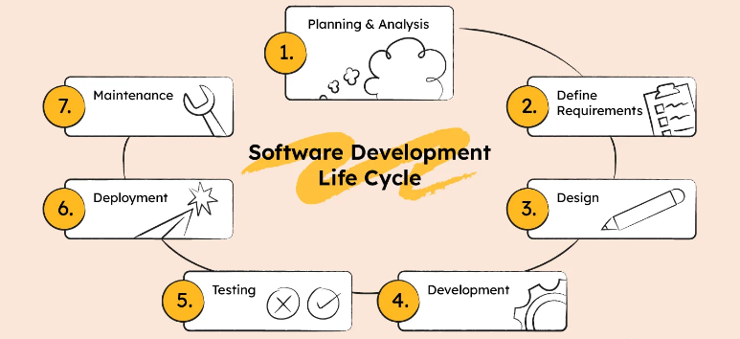

**1. Planning & Analysis**

The first phase of the SDLC is the project planning stage where you are gathering business requirements from your client or stakeholders. This phase is when you evaluate the feasibility of creating the product, revenue potential, the cost of production, the needs of the end-users, etc.

### 2. Define Requirements

This phase is critical for converting the information gathered during the planning and analysis phase into clear requirements for the development team. This process guides the development of several important documents: a software requirement specification (SRS), a Use Case document, and a Requirement Traceability Matrix document.

### 3. Design

The design phase is where you put pen to paper—so to speak. The original plan and vision are elaborated into a software design document (SDD) that includes the system design, programming language, templates, platform to use, and application security measures. This is also where you can flowchart how the software responds to user actions.

### 4. Development

The actual development phase is where the development team members divide the project into software modules and turn the software requirement into code that makes the product.

### 5. Testing

Before getting the software product out the door to the production environment, it’s important to have your quality assurance team perform validation testing to make sure it is functioning properly and does what it’s meant to do. The testing process can also help hash out any major user experience issues and security issues.

### 6. Deployment

During the deployment phase, your final product is delivered to your intended user. You can automate this process and schedule your deployment depending on the type. For example, if you are only deploying a feature update, you can do so with a small number of users (canary release). If you are creating brand-new software, you can learn more about the different stages of the software release life cycle (SRLC).

### 7. Maintenance

The maintenance phase is the final stage of the SDLC if you’re following the waterfall structure of the software development process. However, the industry is moving towards a more agile software development approach where maintenance is only a stage for further improvement.

**4. What is DFD? Create a DFD diagram on Flipkart**

**Ans:**

A Data Flow Diagram (DFD) is a traditional way to visualize the information flows within a system. A neat and clear DFD can depict a good amount of the system requirements graphically. It can be manual, automated, or a combination of both.

It shows how information enters and leaves the system, what changes the information and where information is stored. The purpose of a DFD is to show the scope and boundaries of a system as a whole. It may be used as a communications tool between a systems analyst and any person who plays a part in the system that acts as the starting point for redesigning a system.

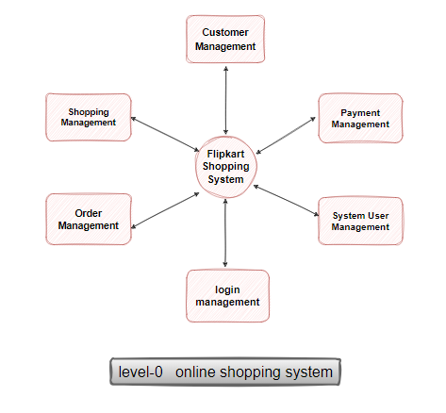

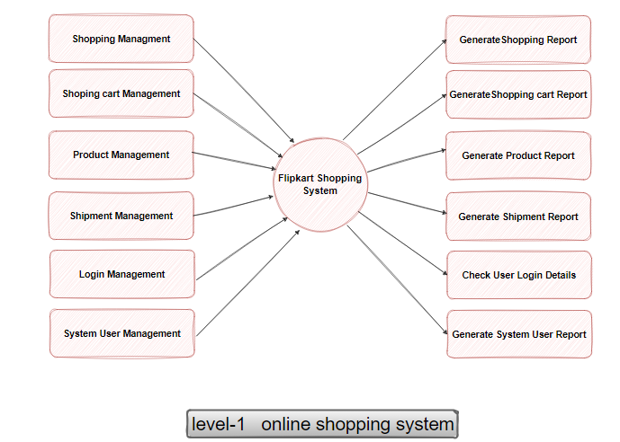

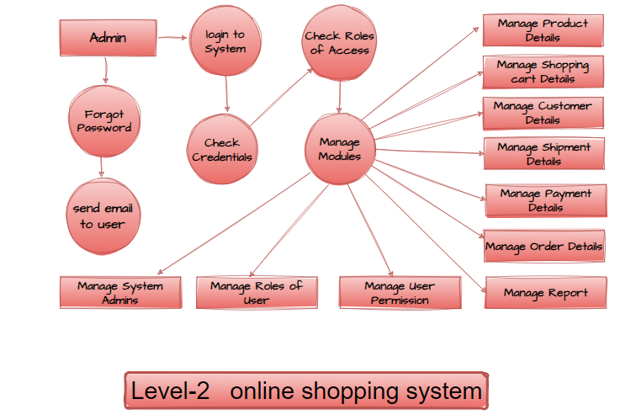

**5. What is Flow chart? Create a flowchart to make addition of two numbers**

* **Ans:** A flow chart is a graphical or symbolic representation of a process. Each step in the process is represented by a different symbol and contains a short description of the process step. The flow chart symbols are linked together with arrows showing the process flow direction.

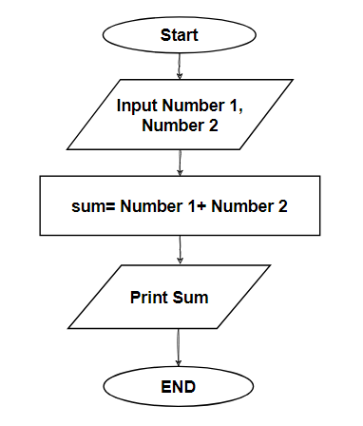.

**6. What is Use case Diagram? Create a use-case on bill payment on paytm.**

**Ans:** In the Unified Modeling Language (UML), a use case diagram can summarize the details of your system's users (also known as actors) and their interactions with the system. To build one, you'll use a set of specialized symbols and connectors. An effective use case diagram can help your team discuss and represent:

